**Exercise 2: Error Handling**

**Scenario 1:** Handle exceptions during fund transfers between accounts.

**Question:** Write a stored procedure **SafeTransferFunds** that transfers funds between two accounts. Ensure that if any error occurs (e.g., insufficient funds), an appropriate error message is logged and the transaction is rolled back.

CREATE OR REPLACE PROCEDURE SafeTransferFunds(

p_from_account_id IN NUMBER,

p_to_account_id IN NUMBER,

p_amount IN NUMBER

) AS

v_from_balance NUMBER;

v_to_balance NUMBER;

BEGIN

BEGIN

SELECT Balance INTO v_from_balance FROM Accounts WHERE AccountID = p_from_account_id;

SELECT Balance INTO v_to_balance FROM Accounts WHERE AccountID = p_to_account_id;

IF v_from_balance < p_amount THEN

RAISE_APPLICATION_ERROR(-20001, 'Insufficient funds for transfer.');

END IF;

UPDATE Accounts

SET Balance = Balance - p_amount

WHERE AccountID = p_from_account_id;

UPDATE Accounts

SET Balance = Balance + p_amount

WHERE AccountID = p_to_account_id;

COMMIT;

DBMS_OUTPUT.PUT_LINE('Transfer completed successfully.');

EXCEPTION

WHEN OTHERS THEN

-- Rollback transaction in case of error

ROLLBACK;

DBMS_OUTPUT.PUT_LINE('Error during transfer: ' || SQLERRM);

END;

END;

/

* Test Case:

BEGIN

SafeTransferFunds(

p_from_account_id => 1, -- Example from account ID

p_to_account_id => 2, -- Example to account ID

p_amount => 100 -- Example amount to transfer

);

END;

/

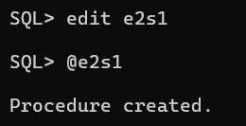

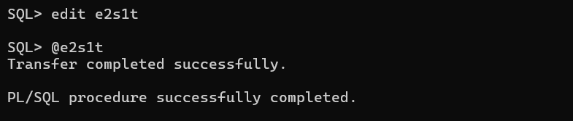

**Scenario 2:** Manage errors when updating employee salaries.

* **Question:** Write a stored procedure **UpdateSalary** that increases the salary of an employee by a given percentage. If the employee ID does not exist, handle the exception and log an error message.

CREATE OR REPLACE PROCEDURE UpdateSalary(

p_employee_id IN NUMBER,

p_percentage IN NUMBER

) AS

v_current_salary NUMBER;

BEGIN

BEGIN

SELECT Salary INTO v_current_salary FROM Employees WHERE EmployeeID = p_employee_id;

UPDATE Employees

SET Salary = Salary * (1 + p_percentage / 100)

WHERE EmployeeID = p_employee_id;

COMMIT;

DBMS_OUTPUT.PUT_LINE('Salary updated successfully for Employee ID: ' || p_employee_id);

EXCEPTION

WHEN NO_DATA_FOUND THEN

DBMS_OUTPUT.PUT_LINE('Employee ID does not exist.');

WHEN OTHERS THEN

ROLLBACK;

DBMS_OUTPUT.PUT_LINE('Error updating salary: ' || SQLERRM);

END;

END;

/

* Test Case:

BEGIN

UpdateSalary(

p_employee_id => 1, -- Example employee ID

p_percentage => 10 -- Example percentage increase

);

END;

/

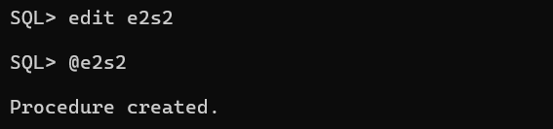

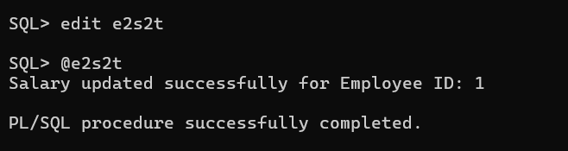

**Scenario 3:** The bank wants to send reminders to customers whose loans are due within the next 30 days.

* **Question:** Write a PL/SQL block that fetches all loans due in the next 30 days and prints a reminder message for each customer.

CREATE OR REPLACE PROCEDURE AddNewCustomer(

p_customer_id IN NUMBER,

p_name IN VARCHAR2,

p_dob IN DATE,

p_balance IN NUMBER,

p_last_modified IN DATE

) AS

BEGIN

BEGIN

INSERT INTO Customers (CustomerID, Name, DOB, Balance, LastModified)

VALUES (p_customer_id, p_name, p_dob, p_balance, p_last_modified);

COMMIT;

DBMS_OUTPUT.PUT_LINE('Customer added successfully.');

EXCEPTION

WHEN DUP_VAL_ON_INDEX THEN

DBMS_OUTPUT.PUT_LINE('Customer with this ID already exists.');

WHEN OTHERS THEN

ROLLBACK;

DBMS_OUTPUT.PUT_LINE('Error adding customer: ' || SQLERRM);

END;

END;

/

* Test Case:

BEGIN

AddNewCustomer(

p_customer_id => 1001,

p_name => 'Alice Williams',

p_dob => TO_DATE('1990-01-01', 'YYYY-MM-DD'),

p_balance => 1500,

p_last_modified => SYSDATE

);

END;

**/**

